Name : AL AZHAR RIZQI RIFA’I FIRDAUS

Class : 1I

NIM : 2241720263

Study Program : D-IV Informatics Engineering

Major : Information Technology

Subject : K3

Lecturer : Kadek Suarjana Batubulan, S.Kom, MT

**Task 1**

* History State Polytechnic of Malang

State of Polytechnic Malang named diploma education program in engineering, Brawijaya University, was opened based on the decree of the director general of higher education, mendikbud No.03/DJ/Kep/1979, established by the government of Indonesia through world bank funds with experts from Swizerland. In 1982, the organizational structure was regulated by presidential decree No. 59 of 1982, named the faculty of non-degree technology, Brawijya Unversity and began accepting students of class I through 4 majors, namely department of electronic engineering, the department of electrical engineering, the department of mechanical engineering , and the department of civil engineering. In 1896, the department of telecommunication engineering, the department of accounting, and the department of commerce administration were opened. The department of accounting and the department of commercial administration receive assistance from the Australian project with Australian experts. Then in 1987 the department of chemical engineering was opened. Furthermore, based on the decree of the minister of national education No./147/O/2004, Brawijaya University Polytechnic has obtained an independent status with the name being the State Polytechnic of Malang. The first director State Polytechnic of Malang is Mr. Umar Nimran. Informatics Engineering was founded in 2010

Photo :

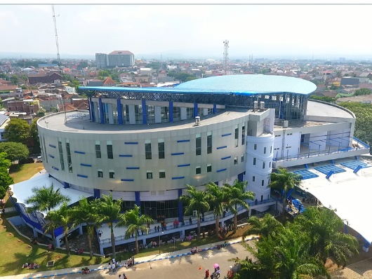 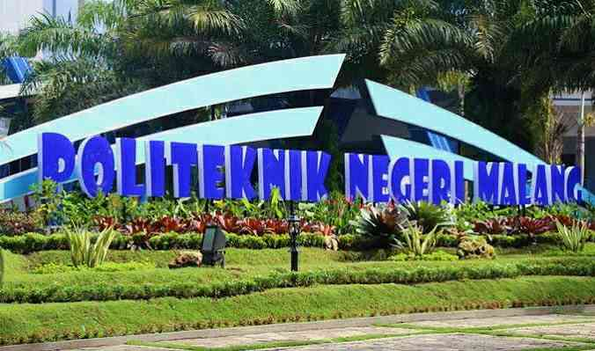

* K3 Devices

1. Hydrant

Location information technology department building

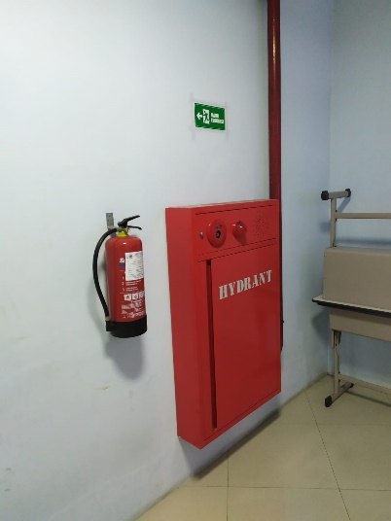

1. Evacuation Route

Location information technology department building

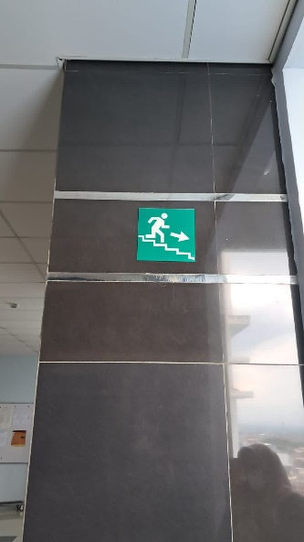

1. Elevator Warning

Location information technology department building

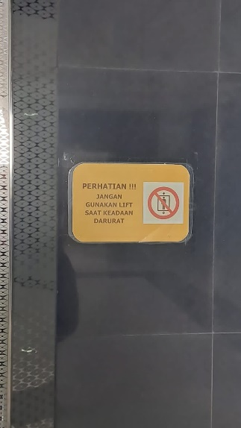

1. Ladder

Location information technology department building

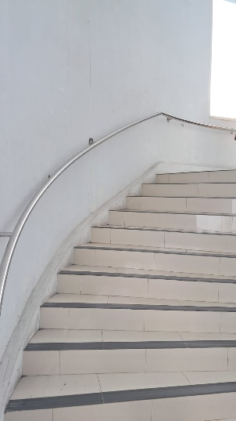

1. Fire Sprinkler

Location information technology department building

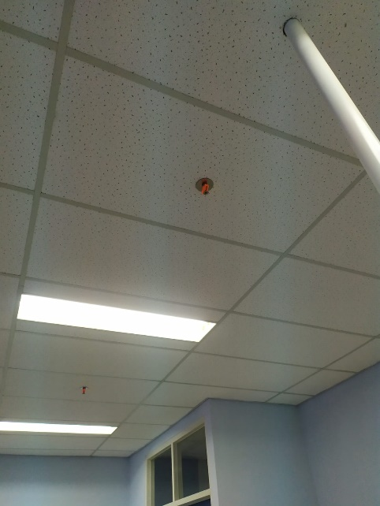

* OSH Symbol



The meaning of the OSH symbol:

* Cross: free from accidents and occupational diseases.
* Gear: work with physical and spiritual health.
* White color: clean and holy.
* Green color: safe, healthy, prosperous.
* Eleven gears: eleven chapters in Law no. 1 of 1970 concerning Work Safety.